**SCOTT DATABASE DEPT AND EMP TABLE**

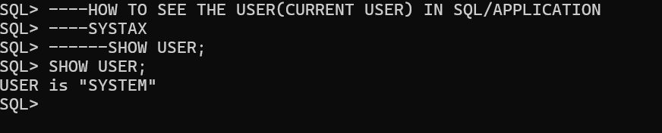

HOW TO SEE ALL THE USER IN SQL/APPLICATION

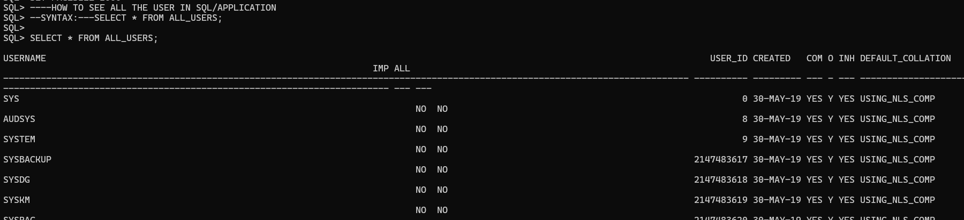

----HOW CREATE A NEW USER

----HOW TO CREATE TABLE IN NEW USER

----HOW INSERT DATE IN NEW USER TABLE

----HOW TO UPDATE DATA IN NEW USER TABLE

----HOW TO DELETE THE DATA IN NEW USER TABLE

STEP -1

**Create user username identified by password;**

CREATE USER SCOTT IDENTIFIED by tiger;

User created

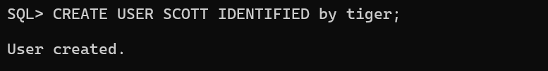

**READ**

NOW YOU HAVE CREATED THE USER

USER NAME IS SCOTT.

WE CAN NOT CONNECT WITH NEW USER SCOTT

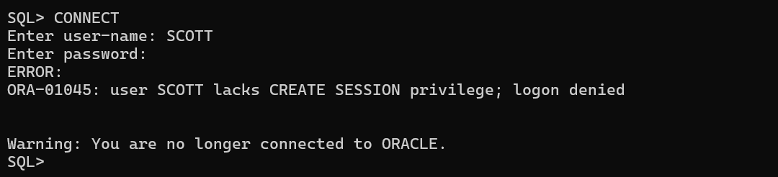

WE CAN NOT CREATE A TABLE IN NEW USER SCOTT

WE CAN NOT INSERT THE VALUES/DATE IN NEW USER SCOTT

WE CAN NOT UPDATE/MODIFY THE DATA/VALUES NEW IN USER SCOTT

WE CAN NOT DELETE/DROP THE DATA IN NEW USER SCOTT

**CONCLUSION:-** WITH OUT CONNECT WITH NEW USER WE CAN NOT CREATE/INSERT/UPDATE/DELETE THE DATE IN NEW USER SCOTT

------TO OVER COME THIS USER (SCOTT) NEED TO TAKE PERMISSION (PRIVILEGES)

----FROM DATABASE ADMINSTRATION (DATABASE ADMIN)

----WE HAVE DATABASE ADMIN i.e(system/tiger)

STEP-2

SQL> connect

Enter user-name: system

Enter password: tiger

Connected

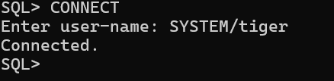

WE HAVE DATABASE ADMIN i.e(system/tiger)

TO CREAT/INSERT/UPDATE/DELETE DATA OF USER.

DATABASE ADMIN i.e (system/tiger)

SHOULD GRANT THE PRIVILEGES (PERMISSIONS) TO USER SCOTT

STEP-3

**Grant all privileges to userName;**

**PRIVILEGES MEANS PERMISSION**

SQL>GRANT ALL PRIVILEGES TO SCOTT; copy/past in SQL Appn

GRANT SUCCEEDED

(Or)

SQL>GRANT DBA TO SCOTT;

GRANT SUCCEEDED

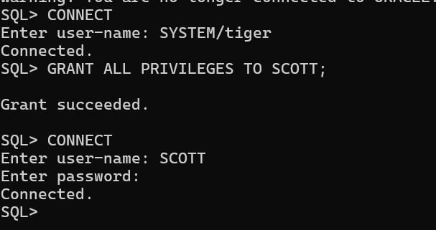

STEP-4

SQL>CONNECT

Enter user-name: SCOTT

Enter password: tiger

Create table DEPT

(

DEPTNO number(2) PRIMARY KEY,

DNAME varchar2(14),

LOC varchar2(13)

);

INSERT INTO DEPT VALUES(10,'ACCOUNTING','NEW YORK');

INSERT INTO DEPT VALUES(20,'RESEARCH','DALLAS');

INSERT INTO DEPT VALUES(30,'SALES','CHICAGO');

INSERT INTO DEPT VALUES(40,'OPERATION','BOSTON');

SELECT * FROM DEPT;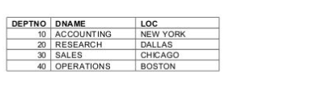

COMMIT;

CREATE TABLE EMP

(

EMPNO NUMBER(4) PRIMARY KEY,

ENAME VARCHAR(10),

JOB VARCHAR(9),

MGR NUMBER(4),

HIREDATE DATE,

SAL NUMBER(7,2),

COMM NUMBER(7,2),

DEPTNO NUMBER(2),

CONSTRAINT F_EMP foreign key(DEPTNO) references DEPT(DEPTNO)

);

INSERT INTO EMP VALUES

(7369, 'SMITH', 'CLERK', 7902, '17-DEC-1980', 800, NULL, 20);

INSERT INTO EMP VALUES

(7499, 'ALLEN', 'SALESMAN', 7698, '20-FEB-1981', 1600, 300, 30);

INSERT INTO EMP VALUES

(7521, 'WARD', 'SALESMAN', 7698, '22-FEB-1981', 1250, 500, 30);

INSERT INTO EMP VALUES

(7566, 'JONES', 'MANAGER', 7839, '2-APR-1981', 2975, NULL, 20);

INSERT INTO EMP VALUES

(7654, 'MARTIN', 'SALESMAN', 7698, '28-SEP-1981', 1250, 1400, 30);

INSERT INTO EMP VALUES

(7698, 'BLAKE', 'MANAGER', 7839, '1-MAY-1981', 2850, NULL, 30);

INSERT INTO EMP VALUES

(7782, 'CLARK', 'MANAGER', 7839, '9-JUN-1981', 2450, NULL, 10);

INSERT INTO EMP VALUES

(7788, 'SCOTT', 'ANALYST', 7566, '09-DEC-1982', 3000, NULL, 20);

INSERT INTO EMP VALUES

(7839, 'KING', 'PRESIDENT', NULL, '17-NOV-1981', 5000, NULL, 10);

INSERT INTO EMP VALUES

(7844, 'TURNER', 'SALESMAN', 7698, '8-SEP-1981', 1500, 0, 30);

INSERT INTO EMP VALUES

(7876, 'ADAMS', 'CLERK', 7788, '12-JAN-1983', 1100, NULL, 20);

INSERT INTO EMP VALUES

(7900, 'JAMES', 'CLERK', 7698, '3-DEC-1981', 950, NULL, 30);

INSERT INTO EMP VALUES

(7902, 'FORD', 'ANALYST', 7566, '3-DEC-1981', 3000, NULL, 20);

INSERT INTO EMP VALUES

(7934, 'MILLER', 'CLERK', 7782, '23-JAN-1982', 1300, NULL, 10);

COMMIT;

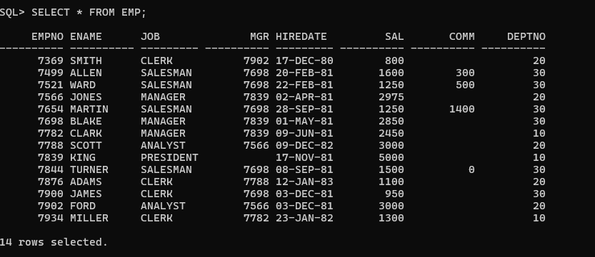

CREATE TABLE SALGRADE

(

GRADE NUMERIC,

LOSAL NUMERIC,

HISAL NUMERIC

);

INSERT INTO SALGRADE VALUES (1, 700, 1200);

INSERT INTO SALGRADE VALUES (2, 1201, 1400);

INSERT INTO SALGRADE VALUES (3, 1401, 2000);

INSERT INTO SALGRADE VALUES (4, 2001, 3000);

INSERT INTO SALGRADE VALUES (5, 3001, 9999);

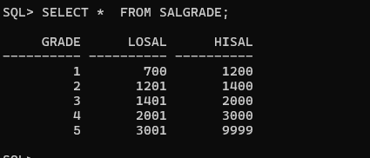

CREATE TABLE BONUS

(

ENAME VARCHAR(10),

JOB VARCHAR(9),

SAL NUMERIC,

COMM NUMERIC

);